**PRACTICAL No.3**

**AIM:** **Write a Program to read two integer numbers and find the sum of the numbers.**

**STEPS:**

#Write a Program to read two integer numbers and find the sum of the numbers.

print("Enter only two numbers to find sum")

num1=input("Enter a number: ")

num2=input("Enter another number: ")

sum=num1+num2

print("Sum: " +sum)

____________________________________________________________________________________________________________________________________________________________________________________________________________________________________________________________________________________________________________________________________________________________________________________________________________________________________________________________________________________________________________________________________________________________________________________________________________________________________________________________________________________________________________________________________________________________________________________________________________________________________________________________________________________________________________________________________________________________________________________________

**SCREENSHOT:**

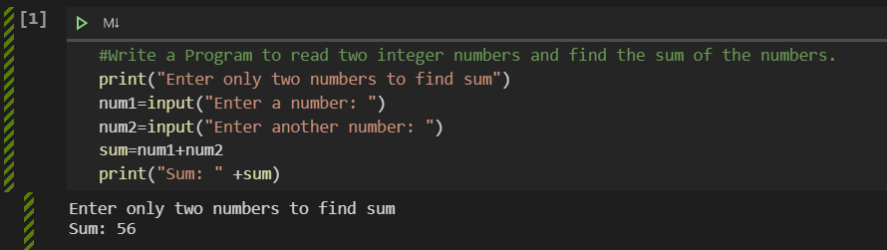

**Date:**